


St. Cuthbert’s RC VA First School

Prince Edward Road



Tweedmouth


Berwick upon Tweed

TD15 2EX

Tel: 01289 307785 Fax: 01289 331717
E-mail admin@st-cuthbertsrc.northumberland.sch.uk
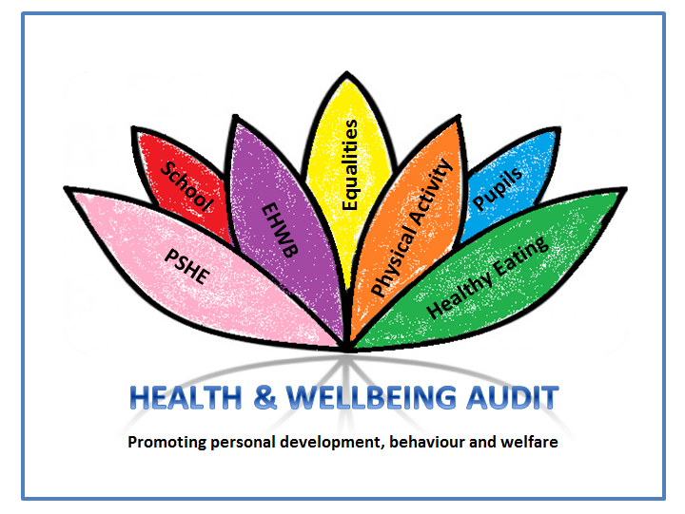
Website www.st-cuthbertsrc.northumberland.sch.uk

Head teacher: Mrs C McGregor

20/03/20
Dear families of St Cuthbert's,
I just wanted to say thank you for your support and your kindness over the last week. It has been very difficult having to close our school to most of you because as you know we normally would do everything in our power to support your children - however at present, these are changed times.
We will miss seeing those of you who will not be in on Monday and beyond (which is most of you) and we ask you to please please follow the governments advice on social distancing at all times starting now and isolating effectively when needed.
I hope to be in school for the foreseeable future albeit with reduced staffing and so if you have any concerns or queries please do not hesitate to contact us and we will try our best to help.
I hope and pray that you and your families will keep safe and well over the coming months and that we will be back to normal soon.
Take care and look after each other...

Mrs McGregor X

May the road rise up to meet you
May the wind be always at your back
May the sun shine warm upon your face;
the rains fall soft upon your fields and until we meet again,
may God hold you in the palm of His hand

