


St. Cuthbert’s RC VA First School

Prince Edward Road



Tweedmouth


Berwick upon Tweed

TD15 2EX

Tel: 01289 307785
E-mail admin@st-cuthbertsrc.northumberland.sch.uk
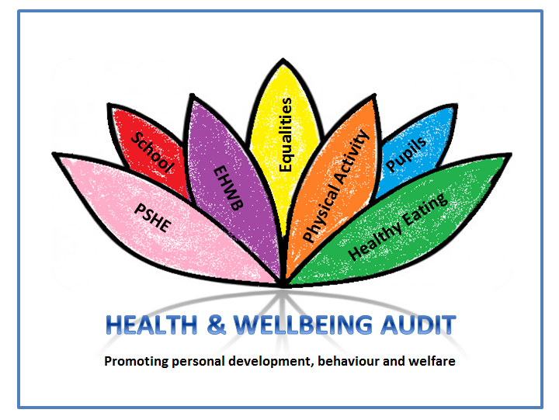
Website www.st-cuthbertsrc.northumberland.sch.uk

Head teacher: Mrs C McGregor

Dear Parent / Carer

School Governing Body

A vacancy has arisen on the Governing Body of the School for the appointment of a Parent Governor.

All Parent Governors must have children at the school (as parent or carer) and must also be elected by the parents and carers of pupils at the school. The period of office for service as a Parent Governor is 4 years and a Parent Governor would not be obliged to resign from office if his/her child leaves the school, they would be able to remain in office until the expiry of the term of office.

At present we have someone who has been on the board for several years and is keen to continue their post as a parent governor. However if anyone would like more information please do not hesitate to contact me before Wednesday 22nd September 2021.

Yours sincerely

C McGregor


Mrs McGregor
Head teacher

